Southern Eagles Soaring

N56LS Standard Cirrus Disassembly / Assembly Procedure. Version 2, 2017

You landed out – so what now? First, hopefully you made arrangements with someone who has a hitch on their car to bring the trailer your way. It is located next to the hangar. Once the trailer is on the field with the glider, here is what to do:

1) Bring the glider directly behind the trailer, nose first.

2) Prepare the trailer by cranking up the front to about 6 inches higher than the back. The combination for the combination lock on the back can be found scratched into the right side of the trailer fin. After opening back of trailer, remove the rack for the horizontal stabilizer from trailer, and put on side. Lower the rear jack with the wrench stored in the trailer. Brace open the door and put the protective carpet in place.
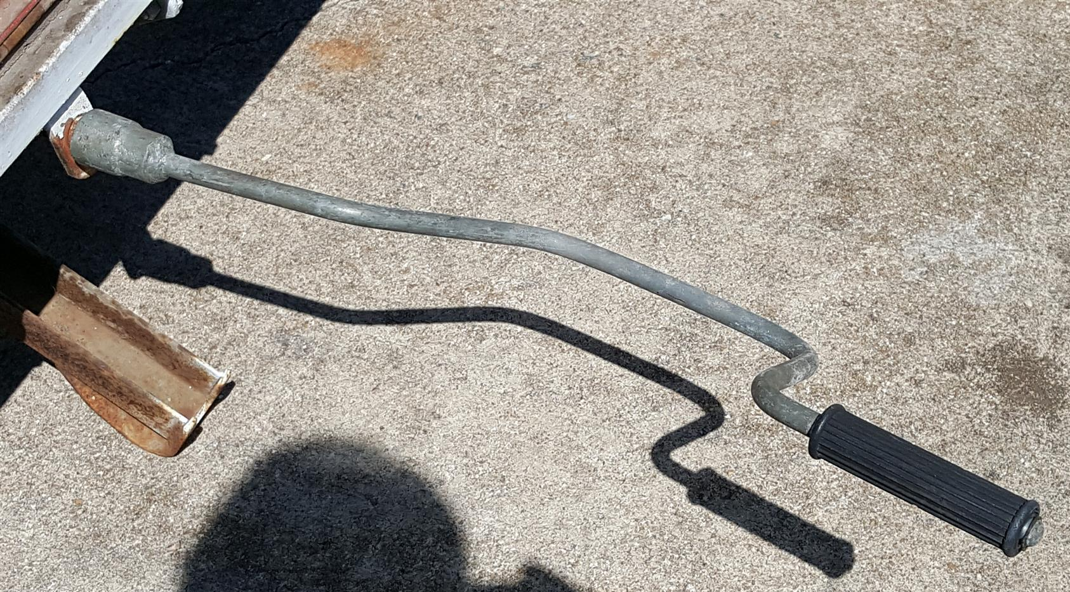
Trailer Rear Jack

3) Fold out ramp behind trailer and put fuselage dolly in position. Lock fuselage dolly with small hooks under the dolly to prevent sliding forward when moving the glider on. Place 2 wing stands (in front of trailer) in reach to place under wings. Place wing carts on each side of ramp. Have wing wheel dollies available. Unscrew anchor nuts from wing carts.
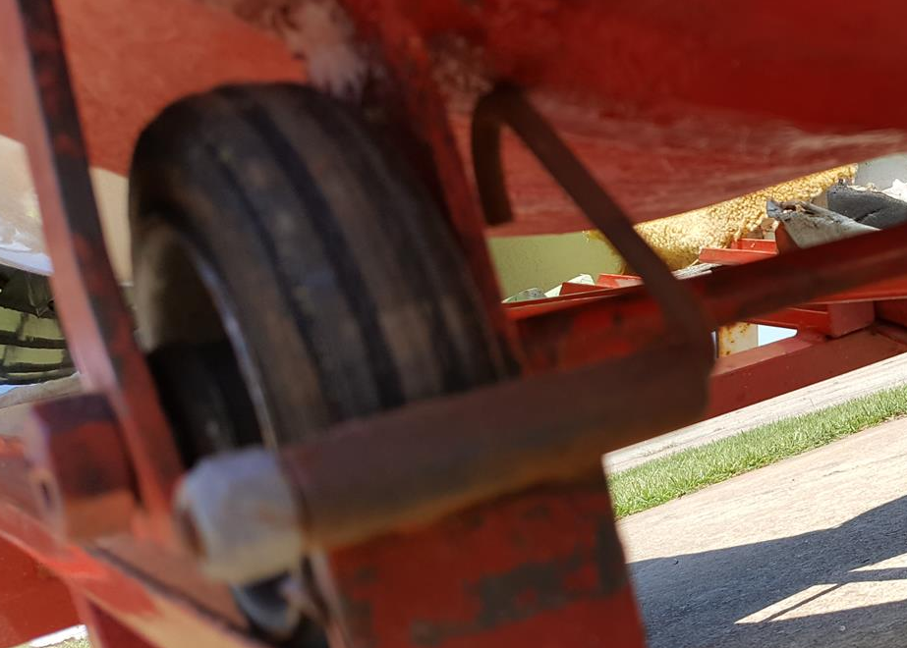 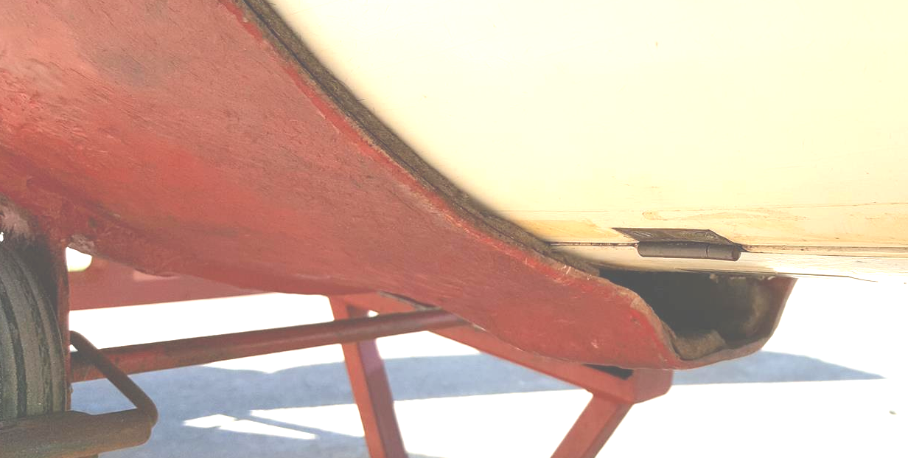
Tow hook will fit in this area

Hooks

4) Slide fuselage on ramp. If tail-dolly was attached, take it off first. Best to have 3 people, so that 1 can hold wings level, one can hold dolly, and one pushes forward. The back end of the dolly should come to about 3 inches in front of gear door. The tow release will end up inside the rear of the dolly that shaped for it. Put 1 wing stand under each wing. Raise wing stand enough so that the wing is lifted up a little. (Maybe 10-15 pounds of pressure). Also put wing wheel on each wing.
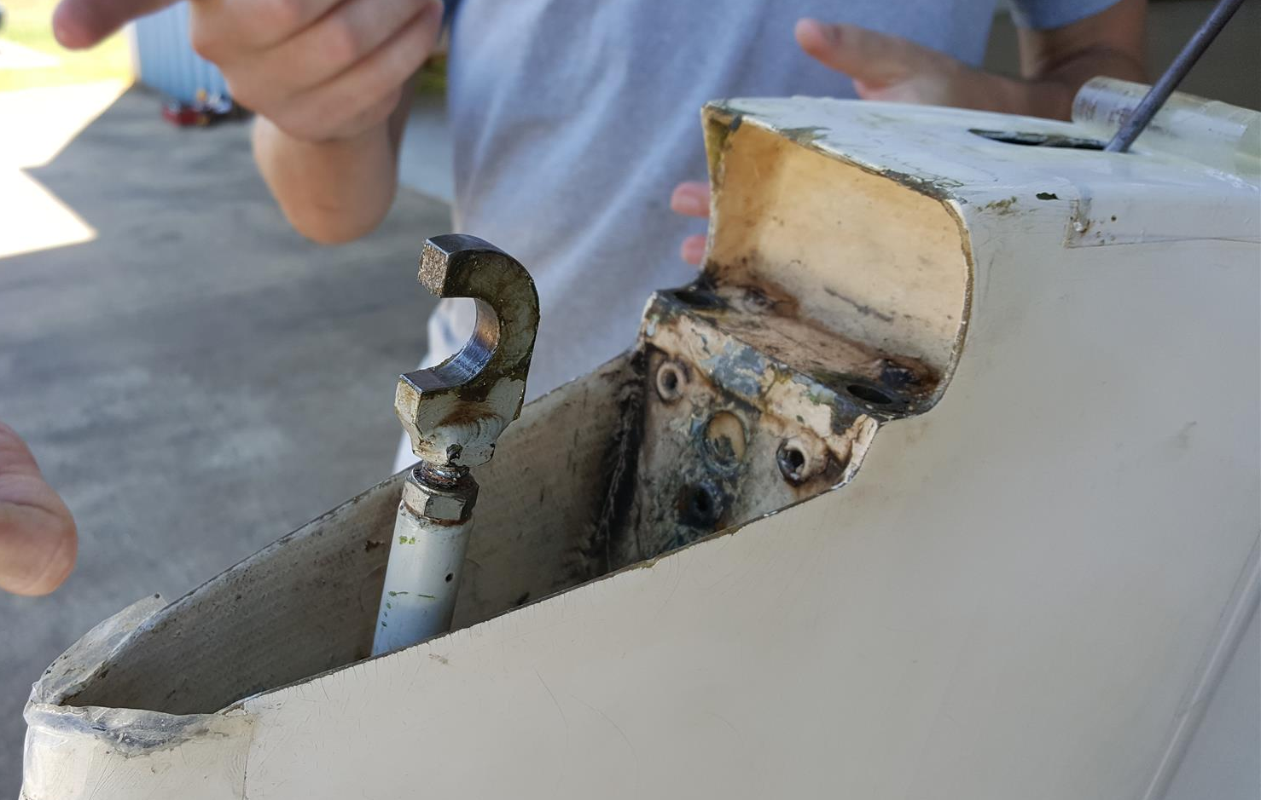
5) Remove horizontal stabilizer: Raise pin underneath tape cover with hook or pliers. Slowly with a twisting motion raise it up. Hold on to the string attached to the washer that this pin goes through. When the pin comes out the washer can fall into the tail if the string is not held! Move the fixture that the pin was securing forward and take the horizontal off with the rear end lifted first. (Pull gently and lift to separate). Put the string with washer around stem on horizontal before securing it with the bungee cord. Place any spare parts in the cockpit. Place the horizontal on the trailer rack for it, the control connection should face inward toward the fuselage, use the bungee cord to prevent it from moving (if the control connection is left facing outward it can damage the wing).

6) Open canopy and raise landing gear.

7) Disengage hotelier couplings from ailerons and spoilers. Start with aileron right side, the spoiler right side, then aileron left, last spoiler left. For each connection, there is a safety pin that needs to be pulled out before the coupling can be disengaged. The safety pins are attached to the couplings with a flexible string – so they will dangle free afterwards. To release the connection you have to roll the sprung release, you will feel the knurls on them. It is pretty much impossible to see what you are doing (if you have a small head you can look, or maybe better take a cell phone picture so you see what is there) best to be familiar with the couplings on each side before trying this the first time. Reach in and find pins by feeling. It helps to jiggle the control (aileron or spoiler) back and forth a little while disengaging. No large forces are necessary (or desirable). You may want to turn the gear warning panel switch off.

8) After all 4 controls rods are disengaged, you are ready to take the wings off. First, remove the mouse-trap looking safety from the main pin. Then one person needs to lift one wing up with enough pressure to unload the weight off the main spar so that the pin can be pulled out. This pressure is about 10-20 pounds (+weight of wing).

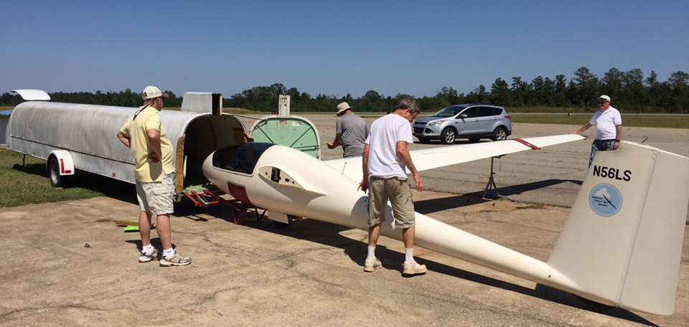
9) Close the canopy!! Also make sure that the large locknuts on the wing carts are removed and in reach before proceeding. Then remove right wing first. One person at wing tip gently rocks a little back and forth and pulls on tip at the same time. One person (better 2) at wing root hold on to the spar as the wing comes out. Pull out wing fully then rotate to vertical position. Walk the tip to the back and place root on wing cart. The spar hole goes through pin on cart and the cart is secured with big nut. Then lift wing cart into trailer and slide in. The wing dolly wheel is on the lateral side of the cart track! This wheel needs to come to rest in the matching depression in the trailer floor (otherwise trailer won’t close later). At front of trailer check that the pin on the wing protrudes through the holding device on trailer. Use small wing nut to secure wing root to holding device. Foam pipe insulation pads get stuffed around the control rods so they don’t flap around during transport.

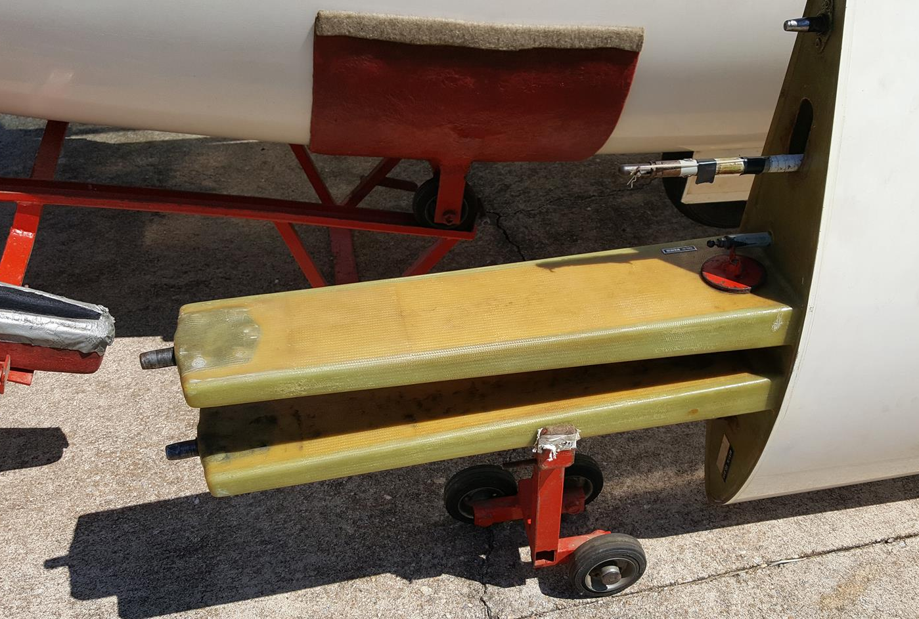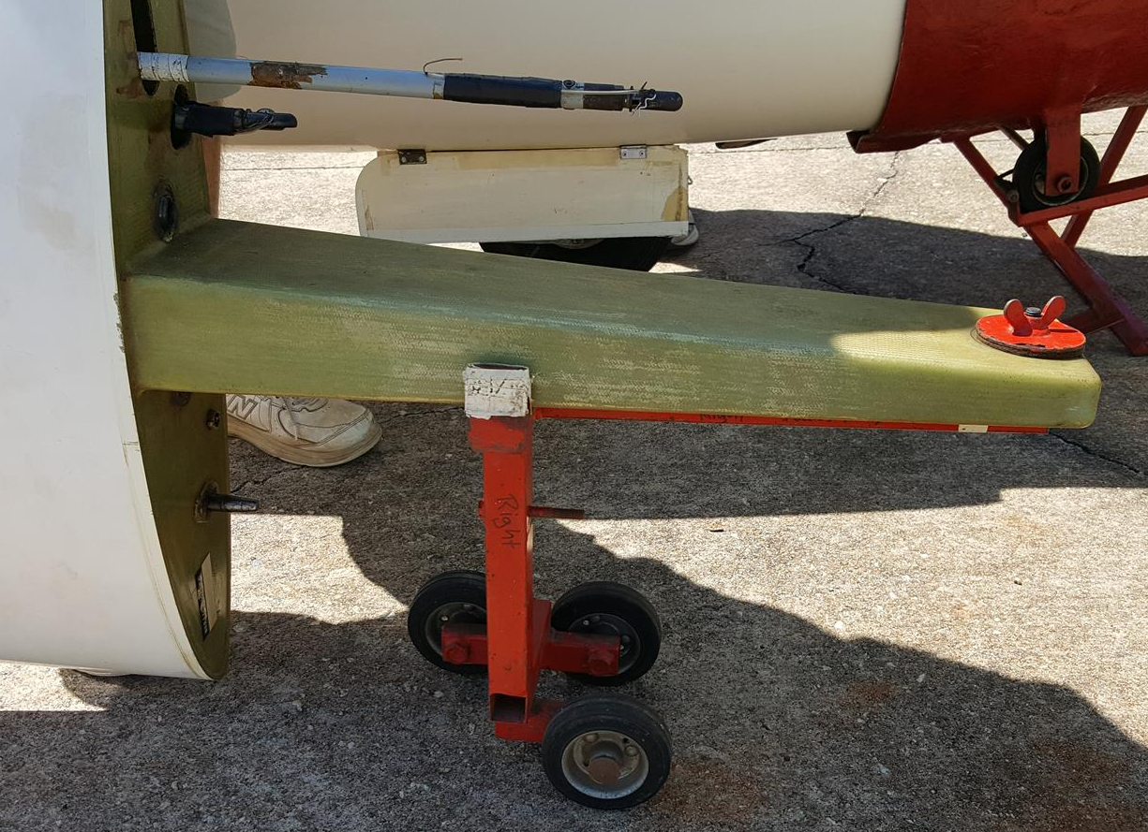
10) Same procedure with left wing.

11) To slide fuselage into trailer, first unlock the little hooks that kept dolly in position on ramp. Align fuselage exactly with long trailer axis then gently push in. Do NOT use rudder to lift fuselage! When the fuselage is fully in tail wheel rests in depression. Place Strap over tail and latch it to prevent it from it bumping up during transport. Slide in foam to protect rudder on each side.
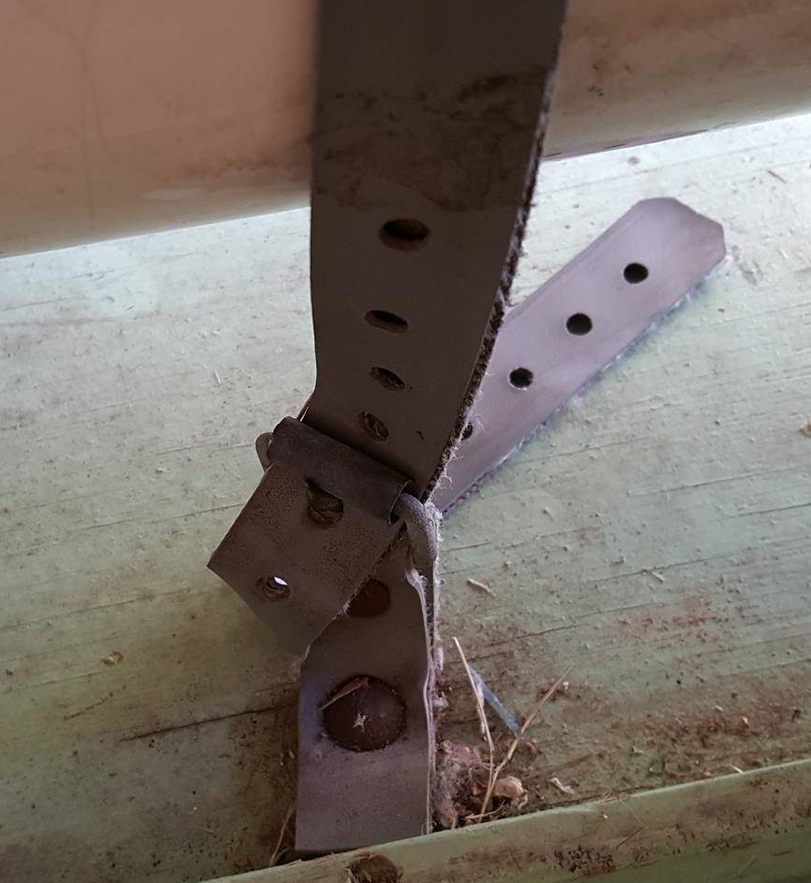
12) Place rack with horizontal on left side of fuselage and secure with threaded bolt. (Reminder the Horizontal’s metal T control fitting must face inward)
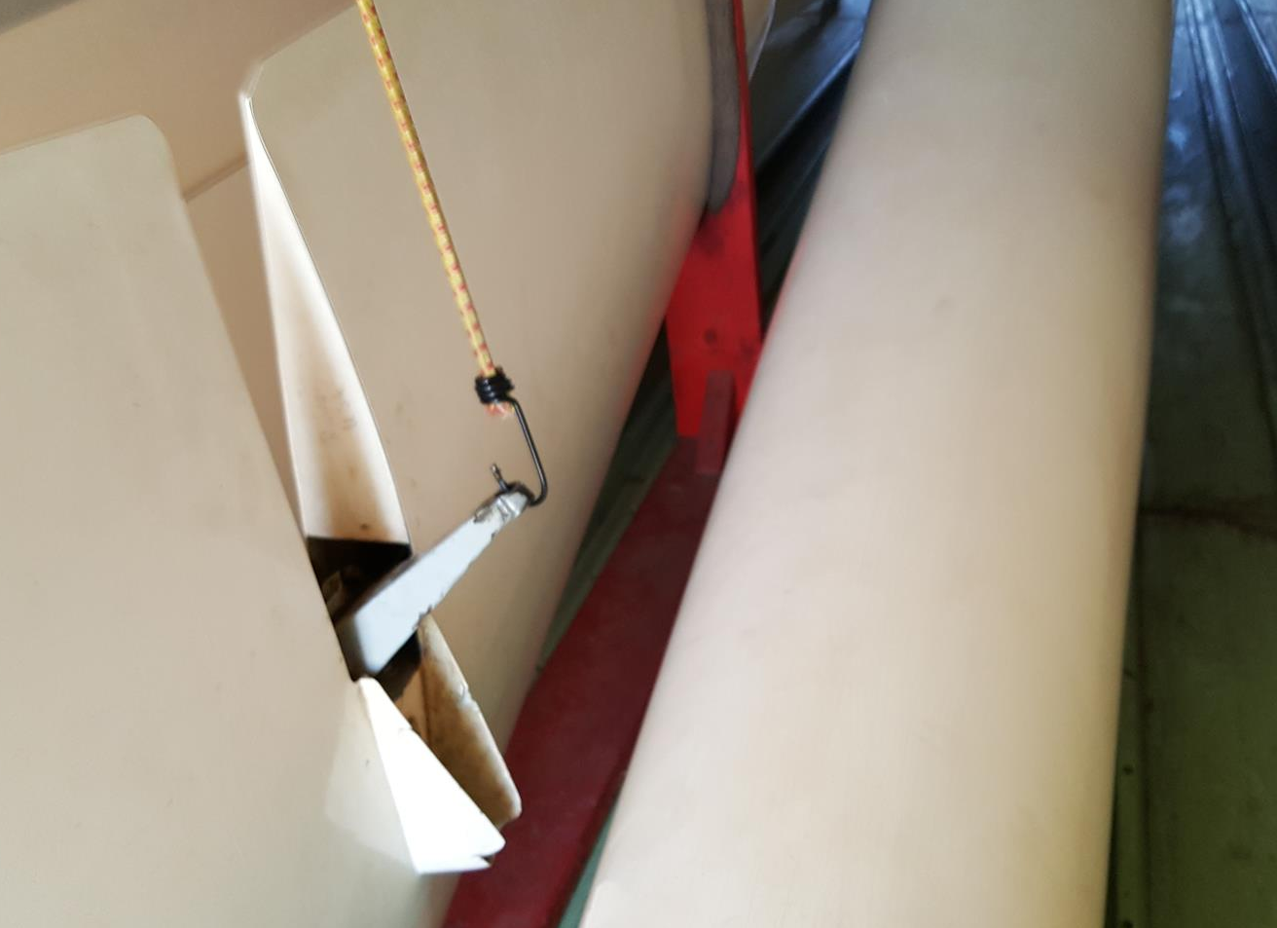 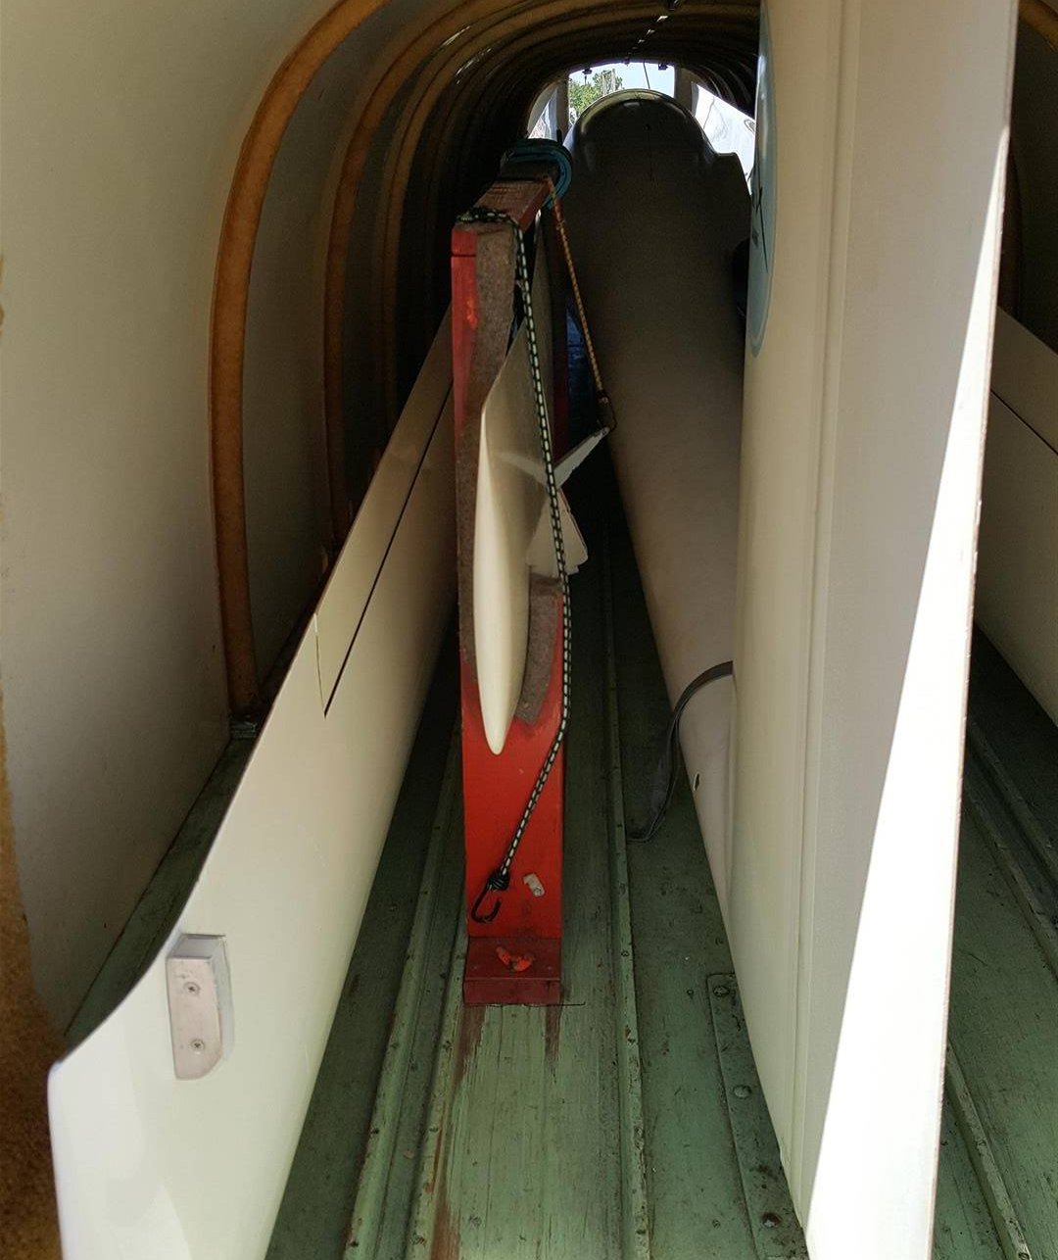

13) Flip up ramp and close trailer up. Before closing front of trailer check that the spoilers are in.

ASSEMBLY (from http://www.standardcirrus.org/Assembly.php)

Now you have a glider in the box, and you might need to assemble it again!
1. If you are new to the Standard Cirrus, it is important to study the wing/fuselage connection mechanism carefully so you understand thoroughly the mechanical issues involved. You should also study the control attachments and imagine how they come together inside the fuselage so you can more easily connect and disconnect them by feel rather than by sight (BEFORE you start assembly! – this is a good time to grease fittings too).
2. After inserting the left wing and placing it on a stand, install the main pin part way (only into the front spar so as not to interfere with the right-wing spar). This prevents the left wing from sliding out as you insert the right wing.
3. Alignment of the left wing is important if the wings are to mate easily when the right wing is inserted. This can be done two ways. The most precise way is to adjust the wing stand until the spar ends in the right side fuselage opening are centered vertically and horizontally. However, some find that by adjusting so the left-wing-to-fuselage gap is uniform fore/aft and top/bottom works well and doesn't involve as much movement from one side of the glider to the other.
4. Inserting the main pin is easy since you can sight right through the main pin holes in the wing spars and see what adjustments are needed. The important thing is the up/down alignment. The wings will seldom be fully inserted so there will be some horizontal alignment error. The tapered end of the main pin takes care of that and pulls the wings together fully. If you are using a helper on the right wing, simply instruct him to raise or lower the wing tip until you get vertical alignment of the holes, then push the greased pin in as you twist it. Insert spar pin safety pin.
5. Are there cracks in the finish of upper fuselage surface near the wing attach points? This is caused by assembly helpers holding an inserted wing to low, thereby forcing the far end of the spar up against the inside of the fuselage with great force. He has no ideas he's doing this. Always instruct helpers to hold the tip at a certain minimum height.
Assembling the Elevator (from http://www.standardcirrus.org/Elevator.php)
And another tricky AND POTENTIALLY DANGEROUS part: Put the horizontal back on Correctly. There is an easily mistaken wrong way to install the horizontal. Review these drawings and you can read more Assembly & Elevator info on the Standard Cirrus organization page.

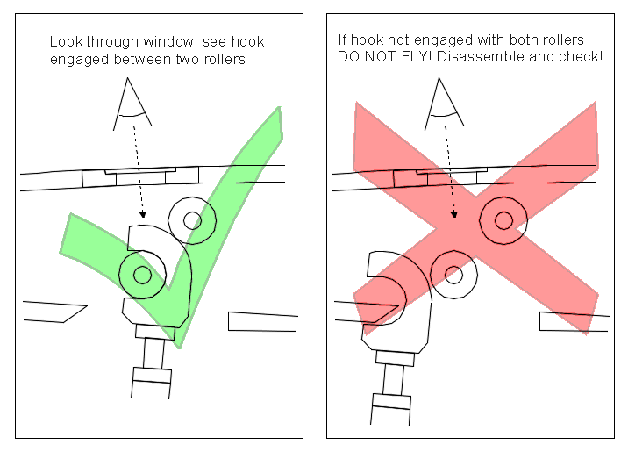
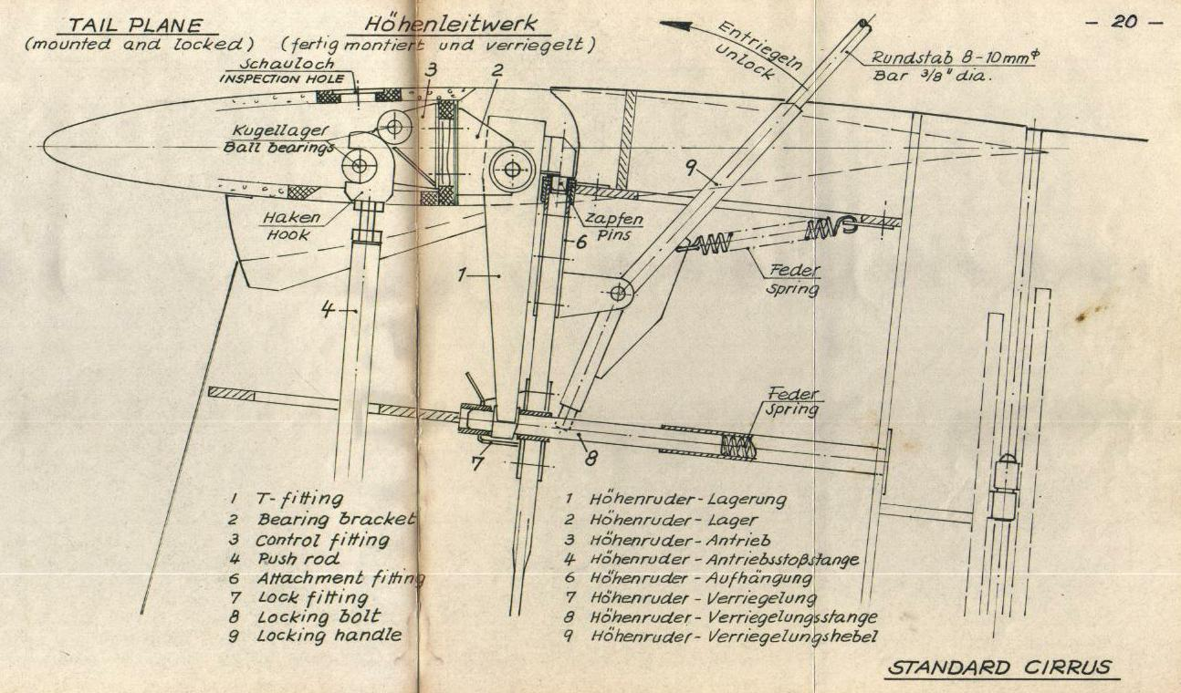Assembly Procedure (Flight and Service Manual, pg. 19)
It is advisable to mount the Elevator by one person only. Lock the trim in a front position first. Put the Elevator onto the top of the vertical tail plane with the nose about 45 degrees down. Keep it in this position, holding it with the left hand. Insert the hook of the push rod⁽⁴⁾ between the ball bearings of fitting⁽³⁾ and push it forward. Drop the trailing edge of the Elevator until the lower end of the T-fitting⁽¹⁾ is sitting on the locking bolt⁽⁸⁾. Push the locking handle⁽⁹⁾ forward, using a bar of about 8 to 10 mm, 3/8" dia. The plane drops when moving it slightly forward. Insert the two short pins on fitting⁽¹⁾ into their bushings on fitting⁽⁶⁾ by rocking the plane gently back and forth. The plane drops again about 5 mm, 3/16". Pull the locking handle⁽⁹⁾ fully back, where it is held in place by two separately acting springs.
Comments
It is important to follow these steps exactly if the elevator is to go on without problems. I have spent as much as half an hour in the hot sun without success, only to discover that the trim was all the way back rather than forward. If the control stick is not far enough forward, the hook will not reach high enough to properly mate with the two ball bearings.
On my ship, when I retract the locking bolt⁽⁸⁾, it remains aft, despite the springs pulling against it. So I usually retract it before setting the Elevator on the fin. In that case, the T-fitting⁽¹⁾ falls in place in one step, rather than first resting on the locking bolt⁽⁸⁾ and then falling in place when the locking bolt⁽⁸⁾ is retracted.
Caution!
Your life depends on getting this right! You can easily secure the T-fitting⁽¹⁾ without engaging the ball bearings. This is extremely dangerous! A Standard Cirrus pilot was killed on August 10, 2002 for this very reason.
Checks
Every owner of a Standard Cirrus occasionally assembles the Elevator incorrectly. They know from experience what to look for. It is very easy to spot the error. They never attach the Elevator without immediately checking their work. The risk is for new owners, who have never seen it done incorrectly and indeed may assume that if it went together, it must be right. If they are not careful, they will accept any response of the Elevator to the control stick as evidence that they got it right. Always perform the following checks to ensure proper assembly:
- Use the inspection hole (window) in the elevator to verify that the hook properly mates with the ball bearings.
- Swing the Elevator through its full range of motion. It should move smoothly, without rattling or the sound of the hook rubbing inside the faring.
- Move the control stick fore and aft, from stop to stop. Do this slowly and rapidly while watching the elevator. The elevator should follow every movement of the control stick smoothly and exactly. It should be evident that the control linkage is both pushing and pulling the elevator.
- Notice the angle of the Elevator with the control stick fully aft. The fairing should be fully concealed within the vertical fin. If the hook is not properly mated with the ball bearings the leading edge of the Elevator will not dip far enough.
- Perform a positive control check! This will confirm that the hook is both pushing and pulling the nose of the Elevator.
A Message from Tom Knauff (26 Aug 2002)
Yesterday, we intentionally incorrectly installed the Elevator on a Std Cirrus. It's not too difficult to do, however, once installed, it is very obvious it is not correct. When the control stick is moved back and forth, the push rod makes a lot of noise as it bangs around inside the Elevator. There is no movement up. The fairing on the bottom, leading edge of the Elevator is well above the normal position so you can see the bottom of the fairing.
Doing a positive control check, if you hold the Elevator in one position, the control stick can feel as though it is connected when you pull or push, however, there is a lot of slop when you switch from pull to push. A slight jiggle cases the elevator push rod to make a lot of noise.
If your clear vision disc is no longer clear so you can see to inspect the connection, consider removing the disc and taping over the hole until you replace the disc. After installing the Elevator correctly, consider painting two thin lines on the rudder to show the normal travel limits of the elevator. This may become an FAA recommendation as well. Thomas Knauff

Tape the wing roots with white electrical tape.

Turn on the gear warning switch if it was turned off at last assembly. Now might be a good time to change the 9V battery that in the fuselage near the spars.

Last not least – a CRITICAL ASSEMBLY CHECK is absolutely required. Make sure the main pin is fully inserted and secured with safety. One person at the front then moves each control to the full range while another person holds gentle pressure against that control surface: Aileron left, Spoiler left, elevator, rudder, Spoiler right, elevator right. Your life depends on all controls being securely hooked up!!

At all times, do not lose the little parts floating around: wing nuts, bolts, tools. Check the area before departing!! It would be good to install the horizontal tail holder back in the trailer including putting the bolt back through the bottom of the holder into the floor.

