- Disconnect trailer from vehicle and raise hitch end until trailer tail rests on wooden block.
- Prepare trailer to receiver glider.
- Remove canopy and put in a safe place.
- Wing stand on left wing.
- Place fuselage support and secure with shoulder straps, wings level.
- Remove horizontal stabilizer.
  - Remove safety and then use special tool to remove the bolt. Replace safety in bolt and place in tool box.
  - Raise leading edge and carefully wiggle stabilizer forward. You may need to move the elevator up and down. Guide roller bearing out of the control rod slot.
- Place stabilizer in safe spot; it goes in trailer last.
- Place rudder lock.
- Remove turtledeck.
- Disconnect the four control hookups.
- The pins are captive. Secure felt washers on the safeties. Use a bungee to secure the loose ends. (See Photo 1)
- Remove the two leading edge pins and stow in toolbox.
- Remove the spar pin safeties and place in toolbox.
- Loosen and remove main spar pin nuts (wrench in tool box). Top pin and nut are marked ”O”. Place nuts in toolbox.
- With one person at the wing tip and two at the root, apply upward pressure to the tips and tap out the spar pins with a plastic mallet. It may be necessary to loosen the pins with the wrench. Stow pins in toolbox.
- Remove wings, right wing first.
- Place right wing on left side of trailer with leading edge down (tip goes in first). Secure spar with bolts, nuts and safeties. Place Alleron locks on Wing.
- Insert left wing on right side of trailer and secure. (See Photo 2)
- Attach carriage guide to fuselage (see Photos 3 & 4).
- Attach nose rope if desired.
- Replace canopy and use canopy cover.
- Insert fuselage taking care to keep tail low enough. Lifting the tail too high causes the guide to fall off the overhead rail and fuselage will fall. (See Photos 5 & 6)
- Tail skid fits in hole in floor. Secure tail with bolt and safety.
- Hang horizontal stabilizer leading edge down, control arm toward fuselage. (See Photo 7)
- Turtledeck goes on floor in front of fuselage. (See Photo 8)
- Stow Fuselage Stand under right rear of fuselage. Stand slides under retention bracket at front, and is secured to the trailer floor with a bolt at the rear.
- Stow Wing Stand. (See Photo 9)
- Stow all gear and use appropriate foam padding to protect glider, wings and tail.
- Close up the trailer and secure the doors being careful that rudder fits into hole in rear door as it is closed.
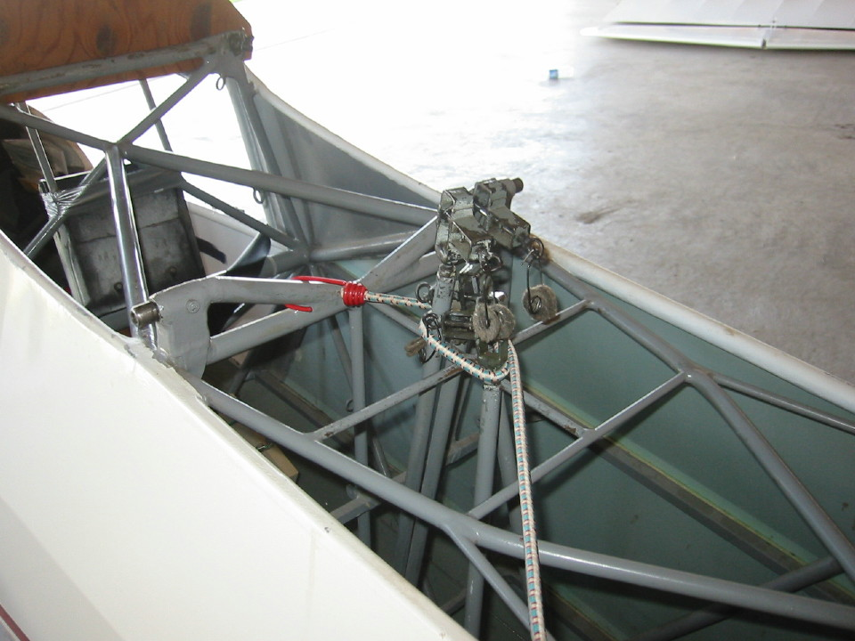

Photo 1. Control Arm Ends Secured to Fuselage.

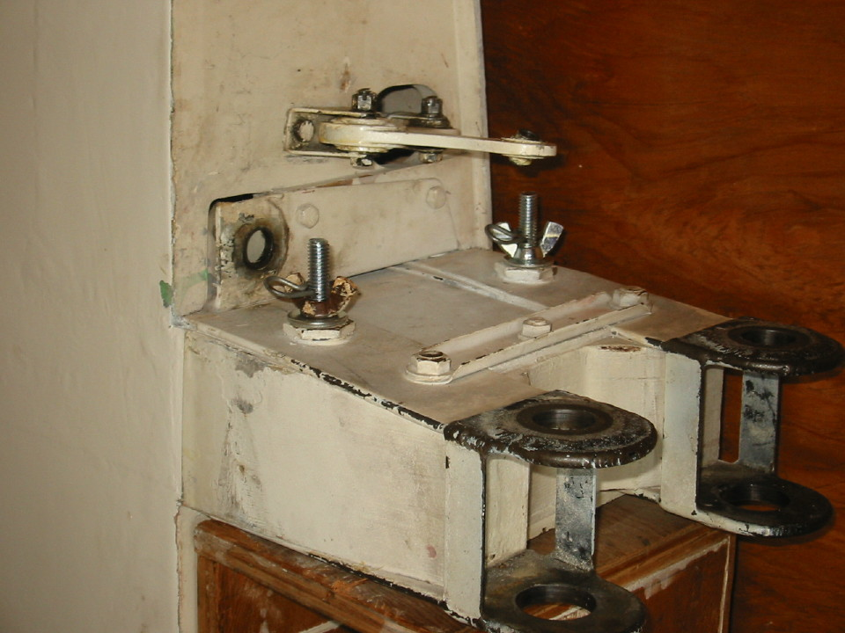

Photo 2. Left Wing Secured on Right Side of Trailer.
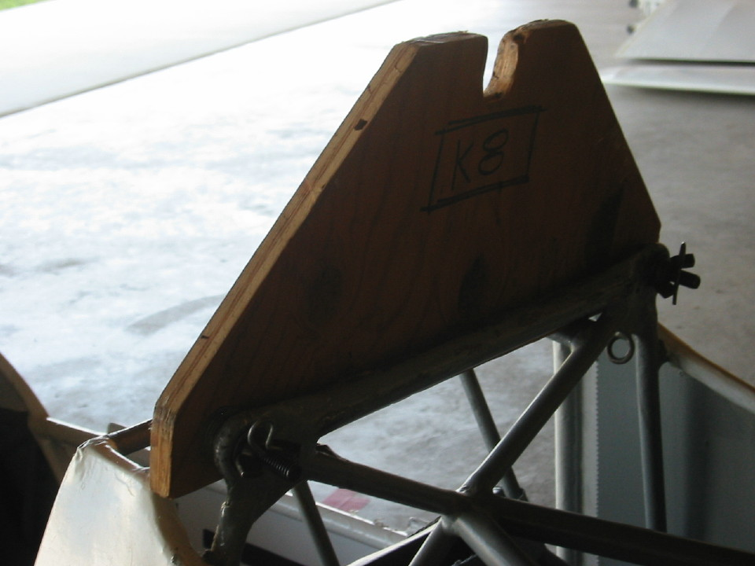

Photo 3. Carriage Guide attached to Fuselage with Wing Nuts and Safeties.

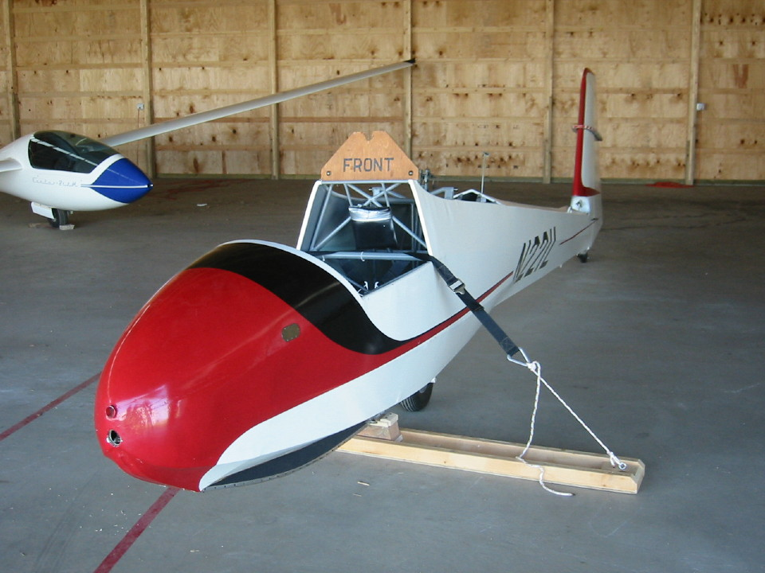

Photo 4. Fuselage on Stand ready to be Inserted into Trailer.
Note: Attach Canopy after Removing Stand.
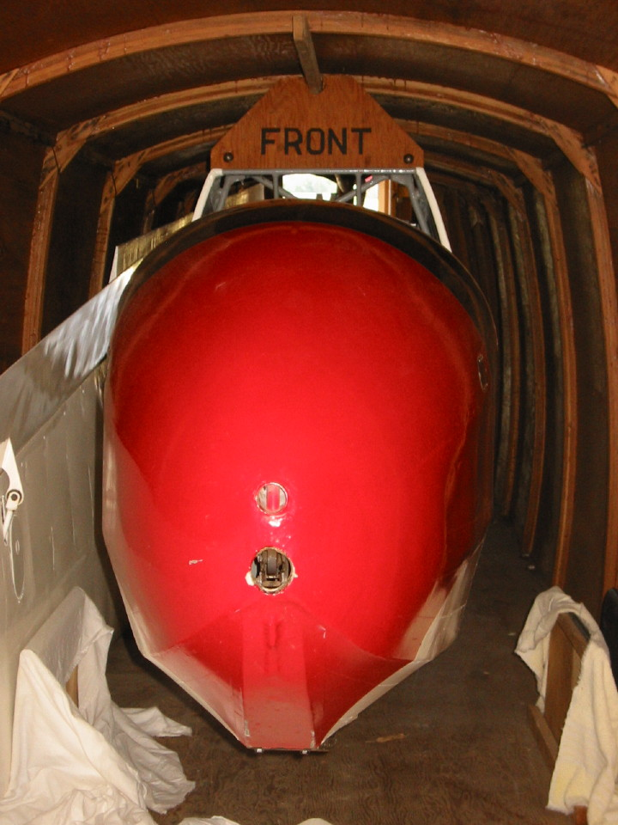

Photo 5. Fuselage and Left Wing in Trailer.
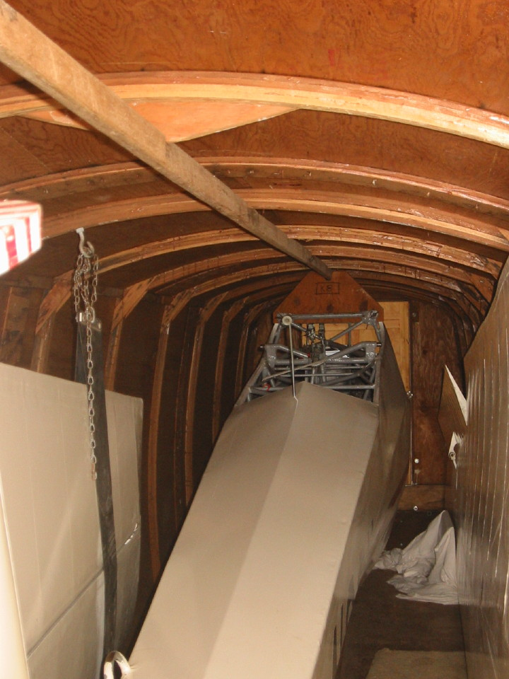

Photo 6. Fuselage, Left Wing, and Elevator in Trailer.
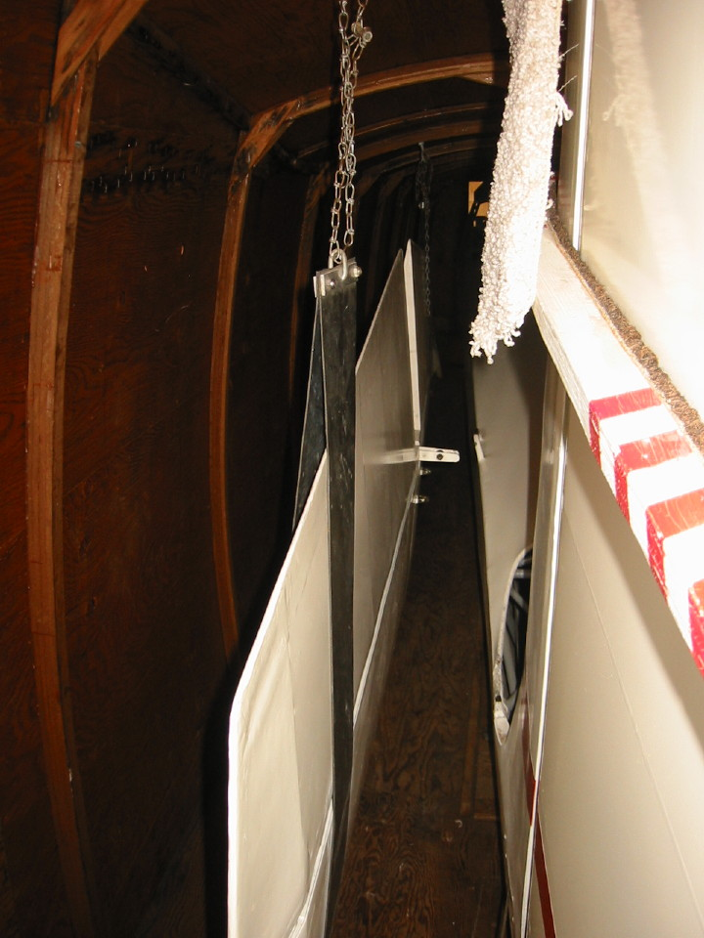

Photo 7. Elevator Hanging in Trailer.
Note: Right Wing (not shown) needs to be inserted first.
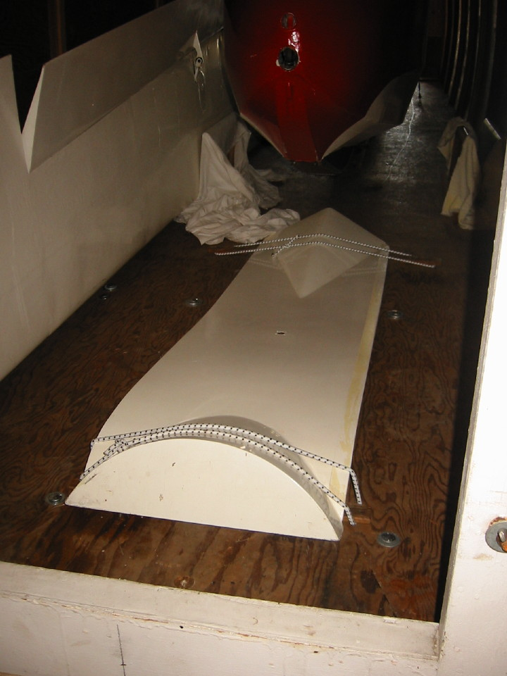

Photo 8. Turtle Deck Secured to Trailer Floor. Note: Antenna may need to be removed.
(Photo does not show Left Wing Alleron lock)
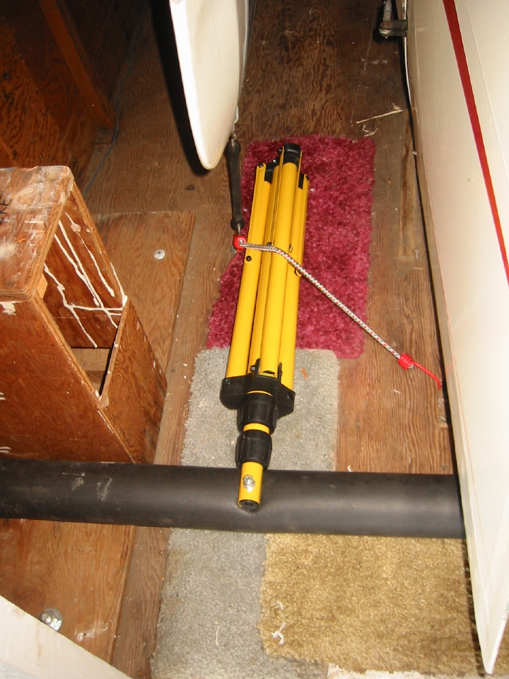

Photo 9. Wing Stand Secured to left rear Trailer floor.

